# Algebra 1 Skills Needed to be Successful in Algebra 2

## A. Simplifying Polynomial Expressions

Objectives: The student will be able to:

* Apply the appropriate arithmetic operations and algebraic properties needed to simplify an algebraic expression.
* Simplify polynomial expressions using addition and subtraction.
* Multiply a monomial and polynomial.

## B. Solving Equations

Objectives: The student will be able to:

* Solve multi-step equations.
* Solve a literal equation for a specific variable, and use formulas to solve problems.

## C. Rules of Exponents

Objectives: The student will be able to:

* Simplify expressions using the laws of exponents.
* Evaluate powers that have zero or negative exponents.

## D. Binomial Multiplication

Objectives: The student will be able to:

• Multiply two binomials.

## E. Factoring

Objectives: The student will be able to:

* Identify the greatest common factor of the terms of a polynomial expression.
* Express a polynomial as a product of a monomial and a polynomial.

## F. Graphing Lines

Objectives: The student will be able to:

* Identify and calculate the slope of a line.
* Graph linear equations using a variety of methods.
* Determine the equation of a line.

## G. Regression and Use of the Graphing Calculator

Objectives: The student will be able to:

* Draw a scatter plot, find the line of best fit, and use it to make predictions.
* Graph and interpret real-world situations using linear models.

# A. Simplifying Polynomial Expressions

## I. Combining Like Terms

- You can add or subtract terms that are considered "like", or terms that have the same variable(s) with the same exponent(s).

*Ex.* 1: 5x - 7y + 10x + 3y

5x - 7y + 10x + 3y

15x - 4y

*Ex.* 2: -8h2 + 10h3 - 12h2 - 15h3

-8h2 + 10h3 - 12h2 - 15h3

-20h2 - 5h3

## II. Applying the Distributive Property

- Every term inside the parentheses is multiplied by the term outside of the parentheses.

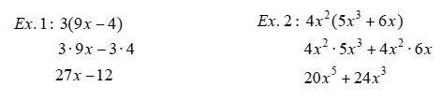

## III. Combining Like Terms AND the Distributive Property

- Sometimes problems will require you to distribute AND combine like terms!!

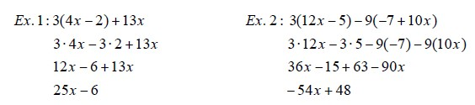

## PRACTICE SET 1

Simplify.

1. 8𝑥−9𝑦+10𝑥+3𝑦 6. −(3𝑥−4)
2. 14𝑦+22−4𝑦2−12𝑦+2𝑦2 7. 2(12𝑎−4𝑏)+3(10𝑎−5𝑏)
3. 5𝑛−(4−12𝑛) 8. (4𝑐+12)+5(4𝑐−10)
4. −3(4𝑏−5) 9. 9(5𝑥−3)−3(4𝑥2−2)
5. 10𝑥(4𝑦+12) 10. −(𝑥−𝑦)+6(7𝑥+5)

# B. Solving Equations

## I. Solving Two-Step Equations

A couple of hints:

1. To solve an equation, UNDO the order of operations and work in the reverse order.

2. REMEMBER! Addition is “undone” by subtraction, and vice versa. Multiplication is “undone” by division, and vice versa.

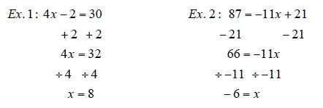

## II. Solving multi-step equations with variables on both sides of the equal sign

- When solving equations with variables on both sides of the equal sign, be sure to get all terms with variables on one side and all the terms without variables on the other side.

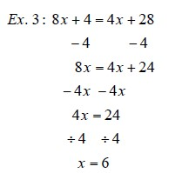

## III. Solving Equations that need to be simplified first

- In some equations, you will need to combine like terms and/or use the distributive property to simplify each side of the equation, and then begin to solve it.

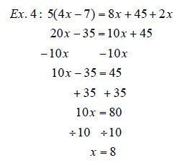

## PRACTICE SET 2

Solve each equation. You must show all work.

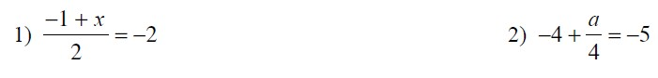

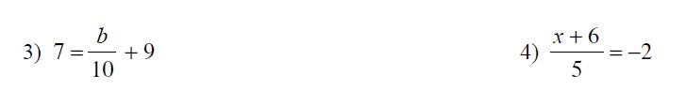

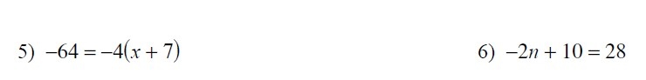

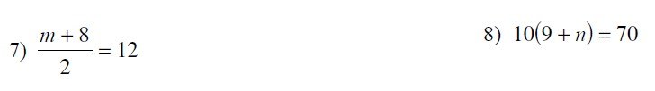

### **IV. Solving Literal Equations**

* A literal equation is an equation that contains more than one variable.
* You can solve a literal equation for one of the variables by getting that variable by itself (isolating the specified variable).

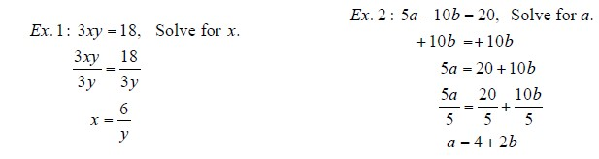

## PRACTICE SET 3

Solve each equation for the specified variable.





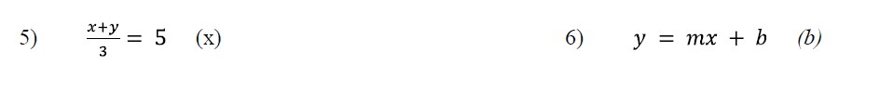

# C. Rules of Exponents

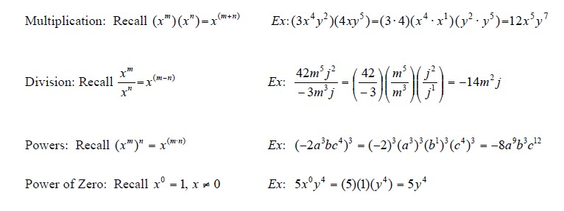

## PRACTICE SET 4

Simplify each expression.

1) (*x*2)3 =  2) (*a*7)5 =  3) (*y*13)4 =

4) (52)3 = 5) (237)8 = 6) (-*y*5)4 =

7) (8*c*5)2 =  8) (-3*h*9)3  9) (*y*4 *d*6)8 =

10) (-*c* 5 *h* 6)4 =  11) (*k*9)5(*k*3)2 =  12) (3*y*6)2 (*x*5 *y*2 *z*)=

# D. Binomial Multiplication

## I. Reviewing the Distributive Property

The distributive property is used when you want to multiply a single term by an expression.

*Ex* 1: 8(5*x* 2 - 9 *x*)

8 " 5*x* 2 + 8 " (-9 *x*) 40 *x* 2 - 72 *x*

## II. Multiplying Binomials – the Distributive method

(x + 6)(x + 10)

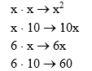F

O

I

L

*x*2 + 10*x* + 6*x* + 60

## *x*2 + 16*x* + 60

(After combining like terms)

Recall: 42 = 4 · 4

*x*2 = *x* · *x*

Ex. (*x* + 5)2

|  |  |
| --- | --- |
| (*x* + 5)2 = (*x* + 5)(*x*+5) | Now you can use the Distributive method to get a simplified expression. |

### **PRACTICE SET 5**

Multiply. Write your answer in simplest form.

1. (𝑥+5)(𝑥−4) 6. (−2𝑥+8)(−9𝑥+4)
2. (𝑥+7)(𝑥−11) 7. (−3𝑥−5)(3𝑥+4)
3. (𝑥−9)(𝑥−3) 8. (𝑥+9)2
4. (𝑥−8)(𝑥+20) 9. (−𝑥+7)2
5. (2𝑥−3)(4𝑥−1) 10. (4𝑥−5)2

# E. Factoring

**I. Using the Greatest Common Factor (GCF) to Factor.**

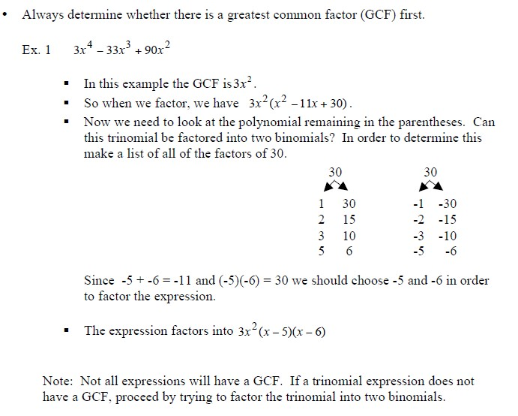

## II. Applying the difference of squares: 𝒂𝟐−𝒃𝟐 =(𝒂+𝒃)(𝒂−𝒃)

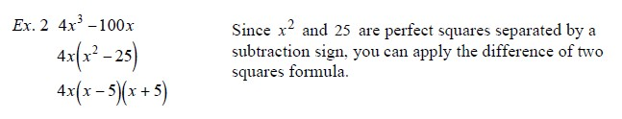

## PRACTICE SET 6

Factor each expression.







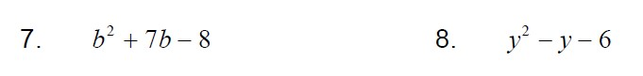

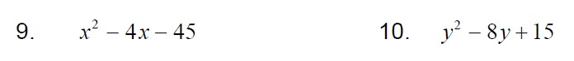



13. 𝑥2−25 14. 𝑥2−100

# F. Graphing Lines

**I. Finding the Slope of the Line that Contains each Pair of Points.**

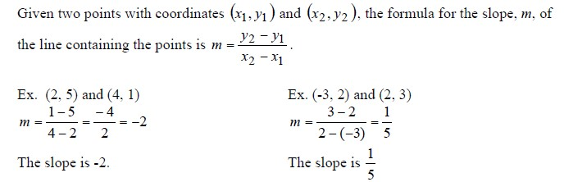

## PRACTICE SET 7

1. (-4, 3) and (1, -2) 2. (1, 6) and (-3, 1) 3. (1, -3) and (-2, -3)

4. (3, -5) and (6, -4) 5. (4, 2) and (-2, -3) 6. (7, -1) and (5, 6)

**II. Using the Slope – Intercept Form of the Equation of a Line.**

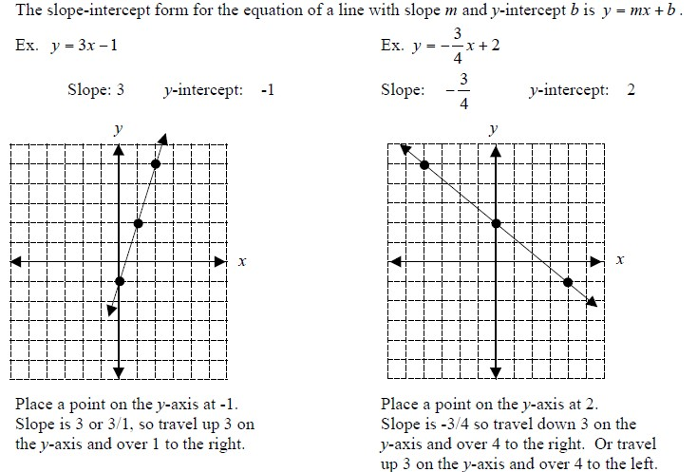

## PRACTICE SET 8

### 1. 𝑦=3𝑥+1

Slope: _____ *y*-intercept: _____ Slope: _____ *y*-intercept: _____

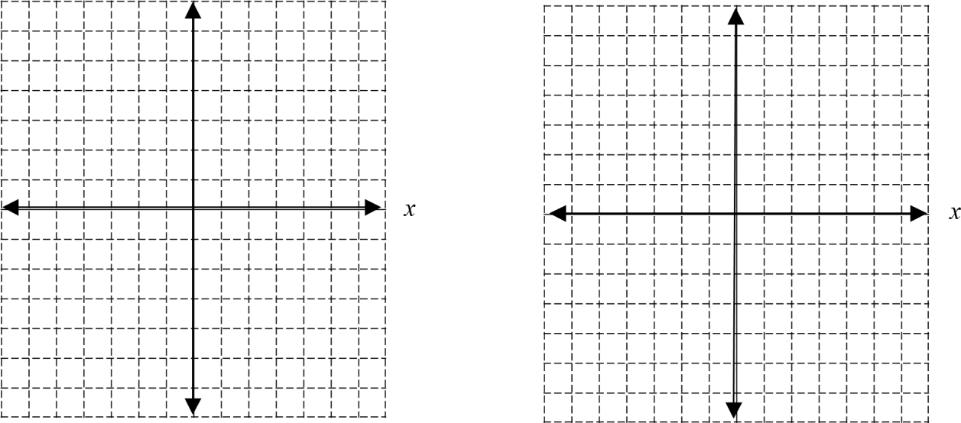

y y

### 4. 𝑦=−2𝑥

Slope: ______________ Slope: ______________ *y*-intercept: ______________ *y*-intercept ______________

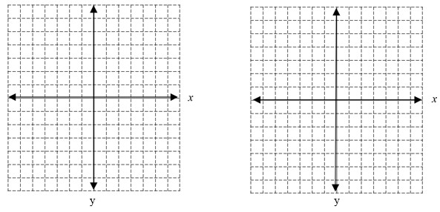

5. 𝑦=−𝑥+4 6. *y*=*x*

Slope: ______________ Slope: ______________ *y*-intercept: ______________ *y*-intercept ______________



**III. Using Standard Form to Graph a Line.**

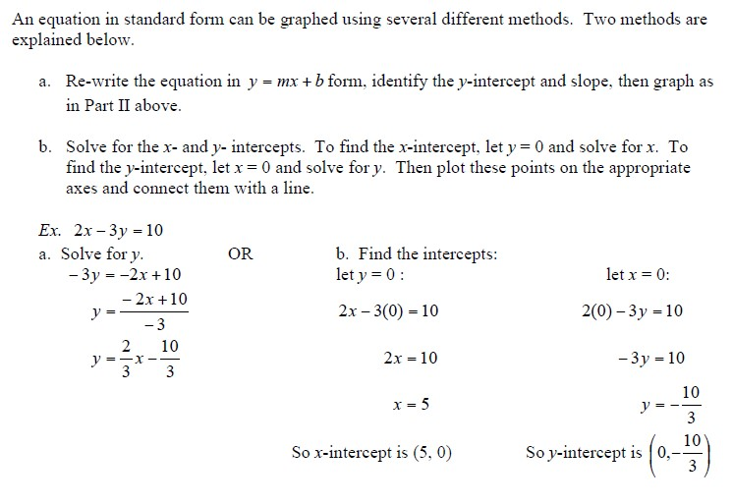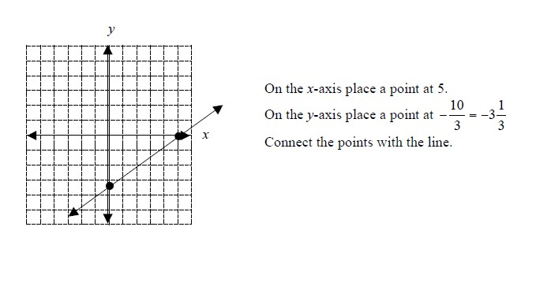

## PRACTICE SET 9

### 1. 5𝑥+2𝑦 =10 2. 3𝑥+𝑦=3

*y y*

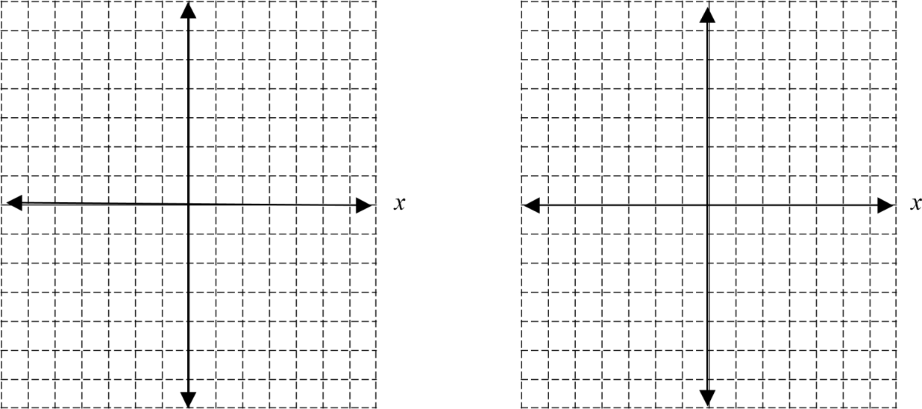

### 3. 𝑥 =4 4. 4𝑥−3𝑦 =9

*y y*

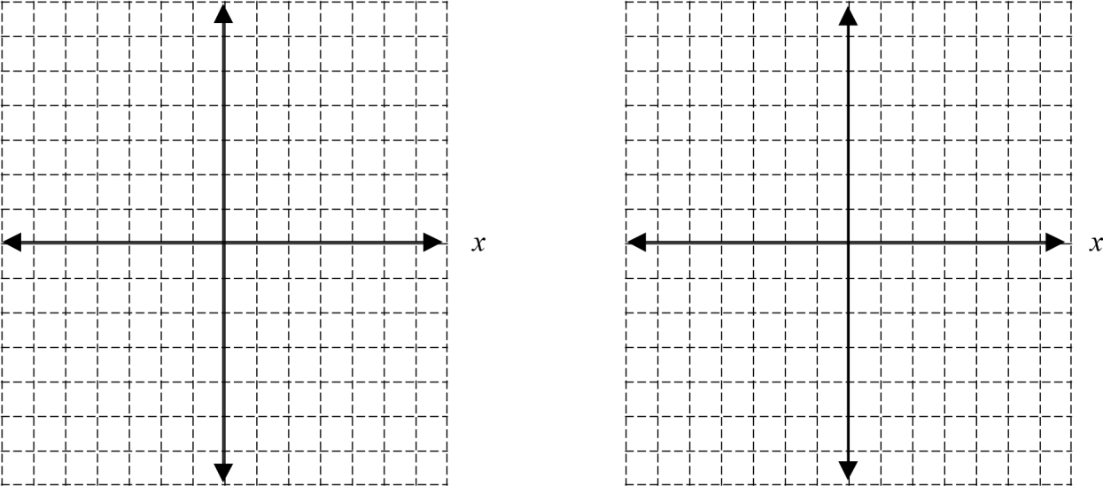

### 5. 𝑦=−3 6. −2𝑥+6𝑦 =12

*y y*

